Infinite Numbers
I walk into a classroom and see that every student is sitting on a chair and every chair has a student sitting on it. We can pair-up the students with the chairs, so there must be the same number of each.

Example 1
We can pair-up the positive integers with the even positive integers:
1 | 2 | 3 | 4 | ...
2 | 4 | 6 | 8 | ...

So there are the same number of positive integers and even positive integers.

Example 2
We can pair-up the positive integers with the squares:
1 | 2 | 3 | 4 | ...
1 | 4 | 9 | 16 | ...

So there are the same number of positive integers and squares.

Example 3
We can pair-up the positive integers with all the integers:
1 | 2 | 3 | 4 | 5 | 6 | 7 | 8 | ...
0 | 1 | -1 | 2 | -2 | 3 | -3 | 4 | ...

So there are the same number of positive integers and integers.

Example 4
Can we pair-up the positive integers with the positive rational numbers?
We cannot write a list of all the positive rational numbers in numerical order, because between any two positive rational numbers we can always find another positive rational number.
for example: half way betweenandis
However, we can write a list of all the positive rational numbers. Look at this table:

... | ... | ... | ... | ... | ...

We can read-off the positive rational numbers along the rows of the table:
…
This is a list of all the positive rational numbers.
note: we omittedbecause we have already hadetc

We can now pair-up the positive integers with the positive rational numbers:
1 | 2 | 3 | 4 | 5 | 6 | 7 | 8 | ...
 |  |  |  |  |  |  |  | ...

So there are the same number of positive integers and positive rational numbers. Even though, between any two consecutive integers there are an infinite number of rational numbers.

Example 5
Can we pair-up the positive integers with the real numbers, between 0 and 1?
We cannot write a list of all the real numbers between 0 and 1, in numerical order, because between any two real numbers we can always find another real number.
for example: half way betweenandis
We thought of a clever trick so we could write a list of all the positive rational numbers, so perhaps we can think of another clever trick so we could write a list of all the real numbers between 0 and 1.
Say, here is our list of all the real numbers, between 0 and 1
0.475922… , 0.887885… , 0.490035… , 0.186792… , 0.676764… , ...

We can now pair-up the positive integers with the real numbers between 0 and 1:
1 | 2 | 3 | 4 | 5 | ...
0.475922... | 0.887885... | 0.490035... | 0.186792... | 0.676764… | ...

Now this won’t do. I can always find a real number between 0 and 1, that is not on the list.
For example 0.59187… is not on the list. How do we know this?
It is not the first number on the list because it has a different first decimal place. It is not the second number on the list because it has a different second decimal place. It is not the third number on the list because it has a different third decimal place, etc
We cannot pair-up the positive integers with the real numbers between 0 and 1.
There are more real numbers between 0 and 1, than positive integers.

Example 6
We can pair-up the real numbers between 0 and 1 with the positive real numbers.
Look at the graphforand

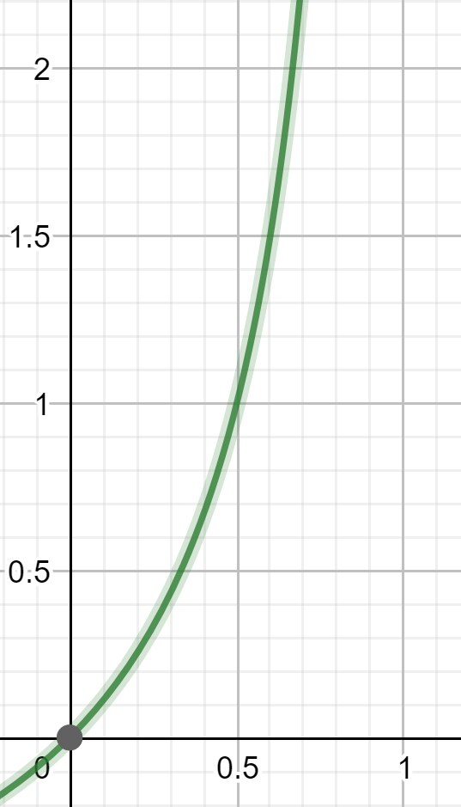

We can pair-up eachvalue with eachvalue.
There are the same number of real numbers between 0 and 1, and positive real numbers.

Subsets:
The finite sethas 3 members:
A subset ofis a selection of none, some or all of the members of
To form a subset, we have 2 choices, include or excludeFor each of these choices we have 2 choices, include or excludeFor each of these choices we have 2 choices, include or excludeSo there arechoices and therefore 8 possible subsets.
The subsets ofare:
In general:
A set withmembers hassubsets

Example 7
is the set of positive integers.
Can we pair-up the members ofwith the subsets of?
Let’s say we have thought of a clever trick and we can pair-up the members ofwith the subsets oflike this:

1 | 2 | 3 | 4 | 5 | ...
 |  |  |  |  | ...
 |  |  |  |  | ...

1 ↔ we put abelow because 1 is not a member of this subset.
2 ↔ we put abelow because 2 is not a member of this subset.
3 ↔ we put abelow because 3 is a member of this subset.
etc
One of the subsets ofisThe set of all the integers with a
Asis a subset ofit must be paired-up with a member of
Let’s sayis the positive integer that we pair-up with
Isaor ainteger?
Ifis ainteger thenis a member ofsois ainteger
Ifis ainteger thenis a member ofsois ainteger
Contradiction.
We cannot pair-up the members ofwith the subsets of
There are more subsets ofthan members of

One of the subsets ofis
We could use an alternative notation to denote this subset.
We could write it as
The 1 in the 1st position denotes: include the integer 1
The 0 in the 2nd position denotes: exclude the integer 2
The 0 in the 3rd position denotes: exclude the integer 3
The 1 in the 4th position denotes: include the integer 4
etc
We can think ofas representing
We can think ofas a real number (written in binary) between 0 and 1
So we can pair-up any subset ofwith a real number between 0 and 1
There are the same number of subsets ofand real numbers between 0 and 1

Letbe the number of positive integers.
Letbe the number of positive real numbers between 0 and 1.
We know thatand

Cantor’s Theorem
A set withmembers will havesubsets and
So we can generate an unending sequence of bigger and bigger infinite numbers:
...

EXERCISE
The rooms in Hilbert’s Hotel hotel are numbered 1, 2, 3, 4, 5 … (this hotel has an infinite number of rooms). All the rooms are taken. A new guest arrives and asks for a room.
“No problem” says the owner “we can fit you in”
a) how can this be done?
Later that day, an infinite number of new guests arrive and each one asks for a room.
“No problem” says the owner “we can fit you all in”
b) how can this be done?

SOLUTION
a) The owner moves:
the person in room 1, to room 2
the person in room 2, to room 3
the person in room 3, to room 4 etc
The new guest is given room 1.
b)The owner moves:
the person in room 1, to room 2
the person in room 2, to room 4
the person in room 3, to room 6 etc
The new guests are given rooms 1, 3, 5, …

